

COLLEGE OF COMPUTING AND INFORMATICS
Assignment – 4
Course Title : Web Technologies Course Code: IT230
Note:
- Submission Deadline: 31/12/2016 at 23:59
- 4 Marks
- Copied assignment will be graded zero mark.

Q1. Which of the following is a "well formed" XML document: [1.0 Mark]
- <firstElement>some text goes here
<secondElement>another text goes here</secondElement>
</firstElement>

- <firstElement>some text goes here</firstElement>
<secondElement> another text goes here</secondElement>

- <?xml version="1.0"?>
<to>Sam</to>
<from>John</from>
<heading>Reminder</heading>
<body>Please save my mobile number !</body>

- <?xml version="1.0"?>
<note>
<to>Sam</to>
<from>John</from>
<heading>Reminder</heading>
<body>Save my Mobile Number!</body>
</note>

Q2: Using XML, Design your class schedule for this semester. Each class has:
Title, Start time, End time and Instructor. [1.0 Mark]

Q3. Given the XHTML page “Main.html”, Write the corresponding JSP page that displays congratulation message if grade > 60 and sorry message if grade < 60 and error message of grade > 100 as the following: [1.0 Mark]
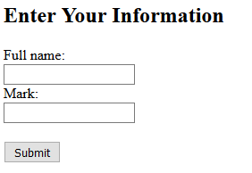
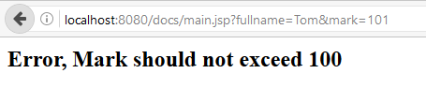
Figure 1 Main.html
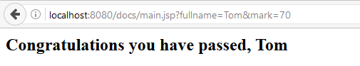
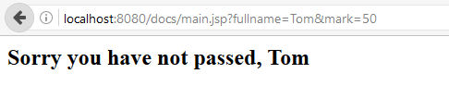
Figure 2 Main.jsp
Main.html
<!DOCTYPE html>
<html>
<body>
<h2>Enter Your Information</h2>
<form action="main.jsp">
Full name:<br>
<input type="text" name="fullname">
<br>
Mark:<br>
<input type="text" name="mark">
<br><br>
<input type="submit" value="Submit">
</form>
</body>
</html>
Q4. Write a simple servlet that displays the input of the following form: [1.0 Mark]
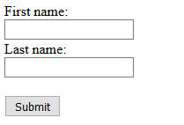
Figure 3 HTML form

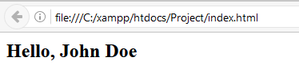
Figure 4 Servlet output

